

HIT 137
Group Assignment 2 (10% Mark)

Group Name: SYDN 54

Group Member:
Luminous Suwal - [S399318]
Subish Shakya - [S399211]
Mim Maya Moktan -[S398117]
Yonish Tamang - [S396870]
Table of Content
Question 1 3
Declaration 3
Program Description 3
Functions and Methods Used 3
Python Code 4
Output: 5
Question 2 6
Declaration 6
Description of program 6
Functions and Methods Used 6
Screenshot of program 8
Output 8
Question 3 9
Description of program 9
Screenshot of program 10
Group Collaboration 16
References 19

Question 1
Create a program that reads the text file "raw_text.txt", encrypts its contents using a simple encryption method, and writes the encrypted text to a new file "encrypted_text.txt". Then create a function to decrypt the content and a function to verify the decryption was successful.
Requirements
The encryption should take two user inputs (shift1, shift2), and follow these rules:
For lowercase letters:
- If the letter is in the first half of the alphabet (a-m): shift forward by shift1 * shift2 positions
- If the letter is in the second half (n-z): shift backward by shift1 + shift2 positions
For uppercase letters:
- If the letter is in the first half (A-M): shift backward by shift1 positions
- If the letter is in the second half (N-Z): shift forward by shift2² positions (shift2 squared)
- Other characters: Spaces, tabs, newlines, special characters, and numbers remain unchanged
Main Functions to Implement
Encryption function: Reads from "raw_text.txt" and writes encrypted content to "encrypted_text.txt".
Decryption function: Reads from "encrypted_text.txt" and writes the decrypted content to "decrypted_text.txt".
Verification function:
Compares "raw_text.txt" with "decrypted_text.txt" and prints whether the decryption was successful or not.
Program Behavior
When run, your program should automatically:
- Prompt the user for shift1 and shift2 values
- Encrypt the contents of "raw_text.txt"
- Decrypt the encrypted file
- Verify the decryption matches the original

Declaration
I hereby declare that this assignment on ‘Password Strength Checker in Python’ is my own work. I have completed this assignment with the assistance of online resources, including ChatGPT [1] and YouTube tutorials. All sources used have been acknowledged in the References section.

Program Description
In this program, the python script asks users for a password and afterward checks its strength according to several conditions. After the user has input a password with the help of the input() function, the script assesses it with the check_password_strength() [2] function, where different rules decide whether the password is Weak, Medium, or Strong. First, the script checks the length of the password using len() to find out whether it is less than 6 characters, between 6-10 characters, or more than 10 characters. Then it utilizes a string method to check if the password contains any digits or uppercase letters. These investigations then divide the password into three categories: Weak, Medium, or Strong. This main function, password_checker (), asks the user for new passwords in a while loop until the user types ‘exit.’

Functions and Methods Used
Input():
- Takes password input from the user
- Allows user to type “exit” to stop the program
len():
- Checks how long the password is
- Helps classify the password based on length
String methods:
- isdigit()- Checks if the password contains at least one digit
- isupper()- Checks if the password contains uppercase letters
- lower()- Converts the user input to lowercase to check for “exit”
Control structures:
- While loop- Repeats the process until the user types “exist”
- If/ elif/ else- Compare properties to determine strength

Python Code
The Python code below implements the password strength checker program. It defines a function that evaluates the entered password based on length, presence of digits, and uppercase letters to classify it as Weak, Medium, or Strong. The code also includes a loop that repeatedly prompts the user for passwords until they type ‘exit’
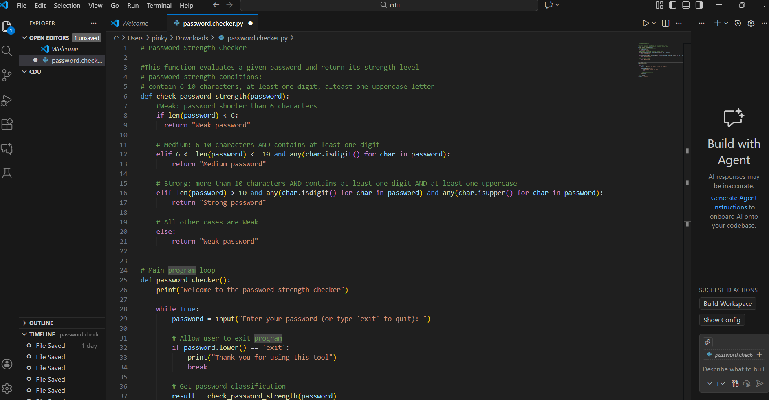
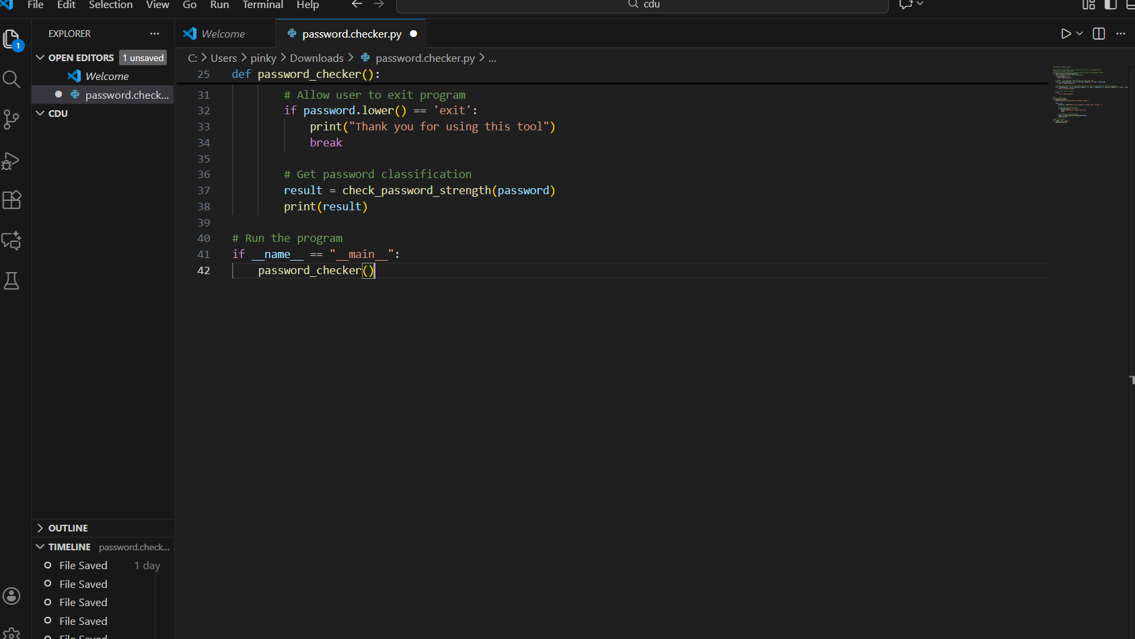

Output:
The output of the program is shown below. It demonstrates how the program checks the strength of the password entered by the user and categorizes it as Weak, Medium, or Strong according to the defined rules. The output also shows that the program continues to ask for new passwords until the user types ‘exit’.
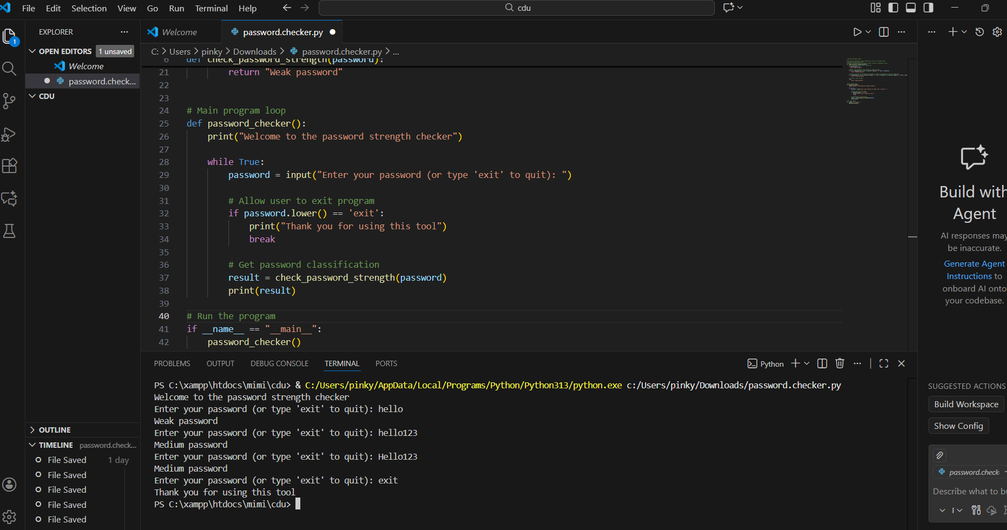

Question 2
Write a program that finds all prime numbers up to a given limit (maximum 100), and display:
• the total count of prime numbers found
• the smallest and largest prime number in the range
• the sum of all prime numbers found

Declaration
I acknowledge the use of ChatGPT [https://chat.openai.com/] to help improve the code and the meeting of criteria for an assessment.
I entered the following prompt: “Check if the code written meets all these criteria: Correctly identifies all prime numbers in the given range • Accurately calculates all statistics • Clear output formatting • Well-structured code with appropriate comments: [my code].” [1]
I used the output as a guideline to improve my code and to make sure that I meet all the criteria needed to get excellent grades in the assessment.
Description of program
This python code asks the user to input a limiting value (maximum limit is 100) and thereafter, it will identify all the prime numbers between the limiting numbers. Once the user has made the input, the program checks the limit and automatically changes the limit to 100 in case the input that has been entered is more than the maximum.
The program has a specific function to determine if a number is a prime number [3], and all the identified prime numbers are saved in a list. After collecting all the primes, the program will show the primes and some statistical numbers, including the smallest prime, the largest prime, the number of total primes, and the sum of the numbers of all the primes.

Functions and Methods Used
Input ():
- Took the limiting number that the user entered.
Custom function:
isprime():
- The function determines if the number is prime or not by:
- The case of numbers less than 2 is thrown back to false.
- Testing the divisibility of numbers increasingly from 2 to the limit given [1].
Range and Loop
- It was used to check all the numbers in order, starting at 2 and going up to the limit and then finding out which ones are prime.
List Operations
- append() - used to insert every prime number that is identified in a list.
- Indexing – used to find the largest and smallest prime.
Built-in functions
- len() - used to identify the count of all prime numbers.
- sum() - used to find the sum of all primes found.
- print() - used to display the primes and statistics results to user
If statements
- Conditional statements were used to validate the input limit. It was also used to check whether the list of prime numbers is null or not.

Screenshot of program
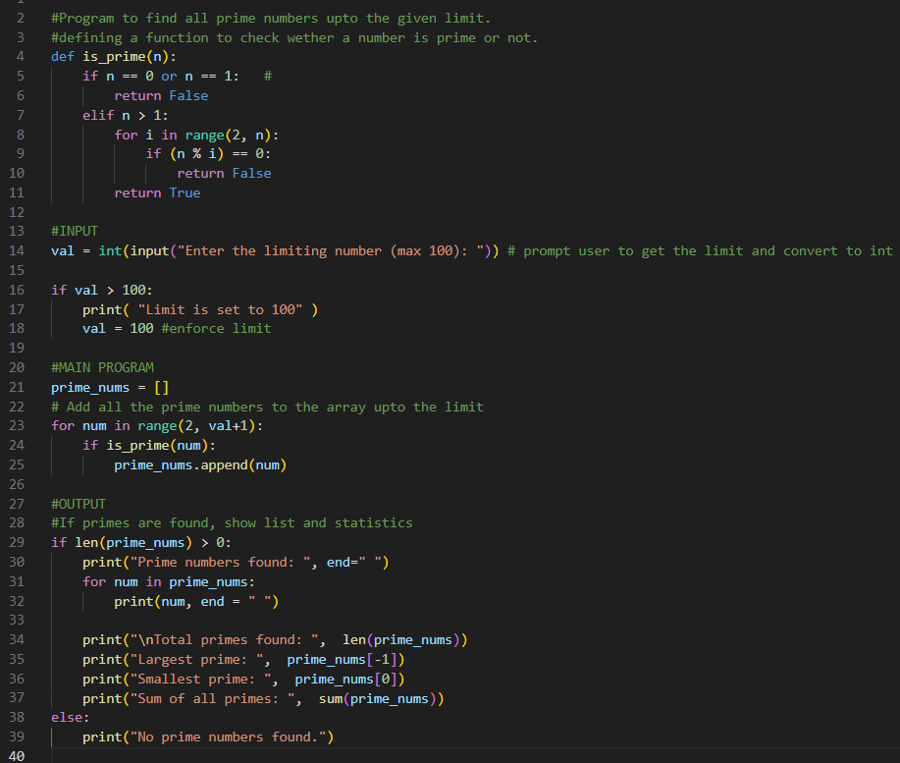

Output
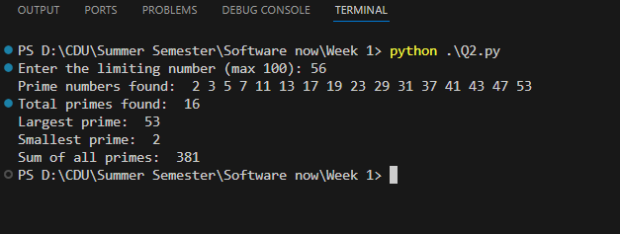

Question 3
Create a program that uses a recursive function to generate a geometric pattern using Python's turtle graphics. The pattern starts with a regular polygon and recursively modifies each edge to create intricate designs.
Pattern Generation Rules:
For each edge of the shape :
- Divide the edge into three equal segments.
- Replace the middle segment with two sides of an equilateral triangle pointing inward (creating an indentation).
- This transforms one straight edge into four smaller edges, each 1/3 the length of the original edge.
- Apply this same process recursively to each of the four new edges based on the specified depth.

Description of the program
This program uses Python's turtle graphics module to create a recursive geometric pattern. The pattern starts with a regular polygon, and each side of the polygon is modified recursively to form an intricate design. The recursion depth controls how complex the pattern becomes.
The program allows the user to enter :
- The number of sides of the polygon
- The length of each side
- The recursion depth
Based on these inputs, the program draws a recursion pattern where each straight line is replaced by smaller segments forming an inward indentation.
Explanation of how the pattern works
The main idea of the pattern is based on recursion. Instead of drawing a straight line for each edge, the program repeatedly modifies the edge using the following steps:
- The edge is divided into three equal parts
- The middle segment is replaced by two sides of an equilateral triangle pointing inward, creating an indentation.
- This converts one straight edge into four small edges, each having one-third the length of the original edge.
- The same process is applied again to each of the new edges until the recursion depth reaches zero.
When the recursion depth is zero, the program simply draws the straight line. Otherwise it keeps breaking the edge into smaller segments and applying the same transformation.

Functions used
draw_recursive_edge(length, depth)
This is the core recursive function responsible for creating the pattern
- If depth is 0, the turtle moves forward and draws a straight line.
- If depth is greater than 0, the edge is divided
- The function draws four smaller edges turning right by 60 degrees, left by 120 degrees,and then right by 60 degrees to form an inward pointing triangular indentation.
- Each recursive call reduces the depth of one, ensuring the recursion eventually stops.
draw_recursive_polygon(sides, length, depth)
This function draws the overall polygon
- It calculate the angle required to turn after each side using 360/ sides
- For each side of the polygon, it calls draw_recursive_edge function to draw the modified edge.
- The turtle then turns to continue drawing next.
read_input(prompt, minimum)
This function ensures valid user input
- It ask the user for input, if invalid input is entered it repeatedly asks for input until a valid input is entered
- It also check that the value meets the minimum required condition
- It prevents runtime errors caused by invalid inputs
main()
The main function controls the execution of the program
- It collects user inputs for sides, length and recursion depth.
- It initializes the turtle screen and sets the drawing speed.
- The turtle is positioned properly before starting the drawing.
- Finally, the recursive polygon is drawn and the turtle window remains open until closed.
Thus, this program demonstrates how recursion can be used to generate complex geometric patterns from simple rules. By repeatedly modifying each edge of a polygon, the design becomes more detailed as the recursion depth increases. The turtle graphics module makes it easy to visually understand how the recursion works in a graphical way.

Screenshot of code
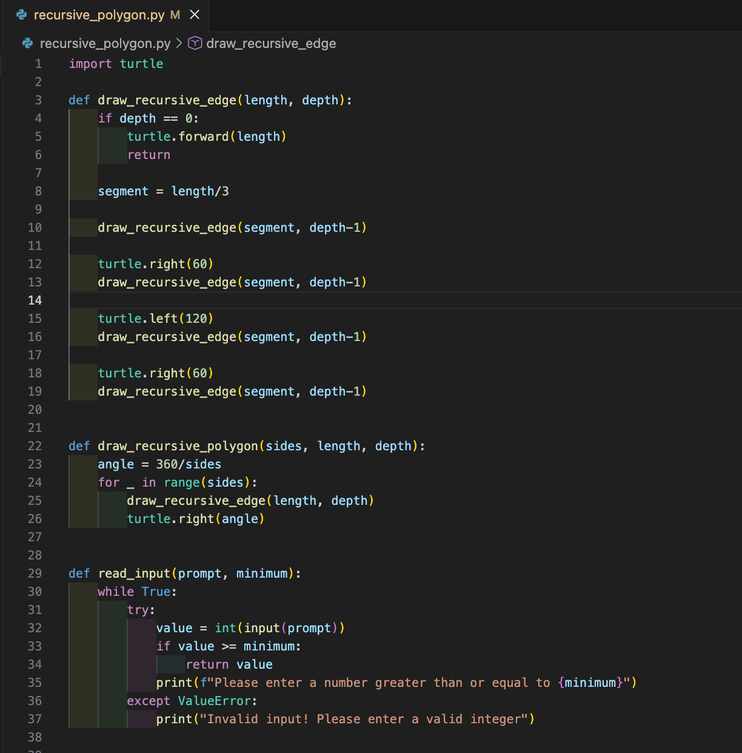
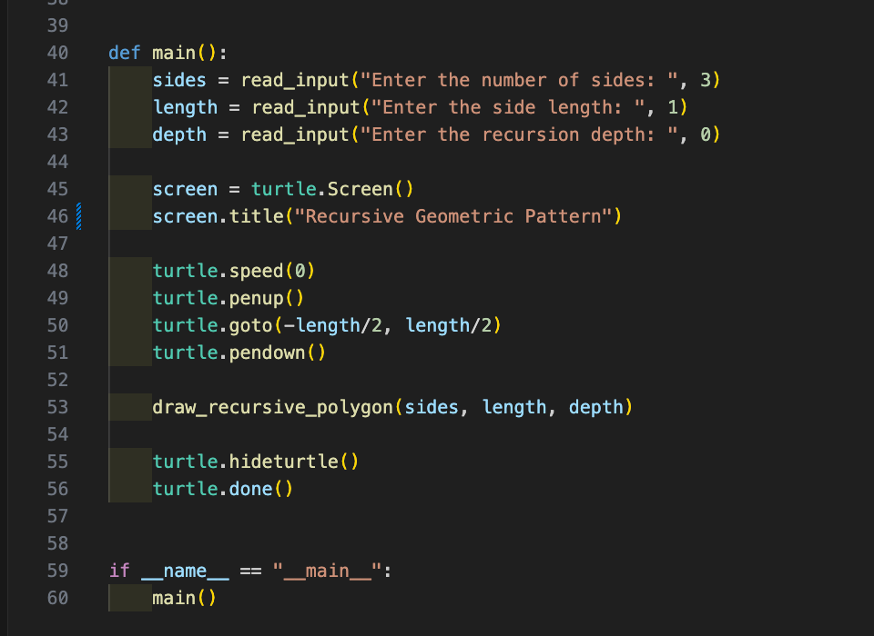

Output
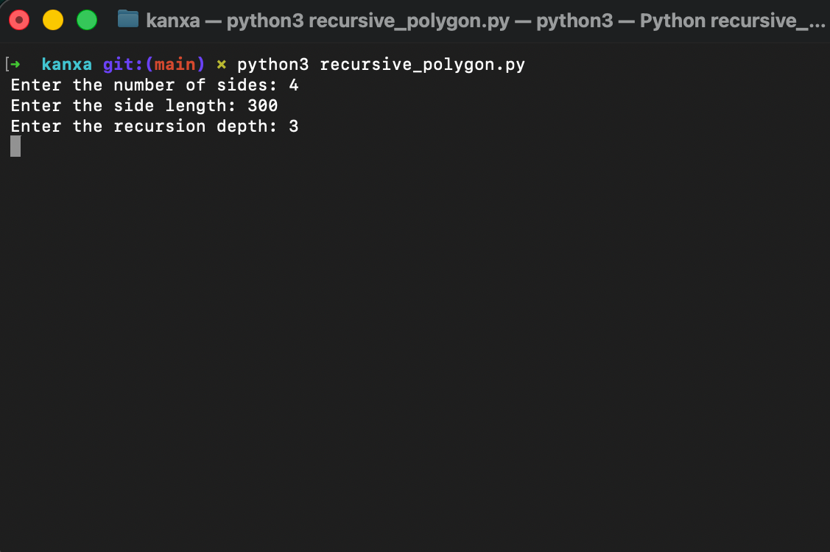
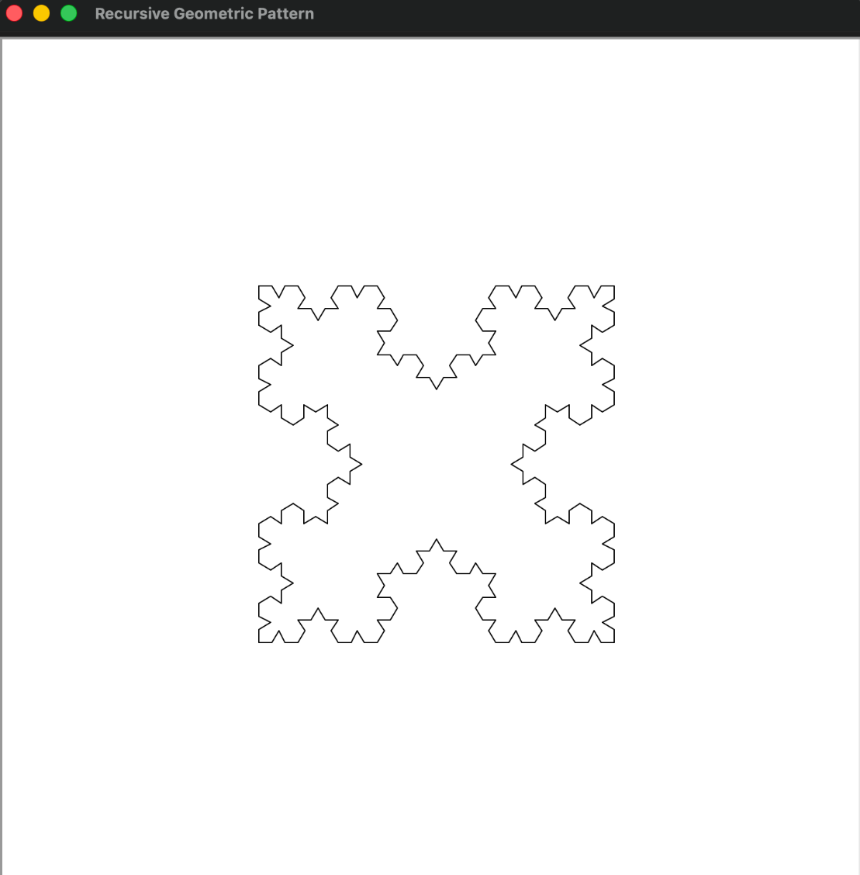
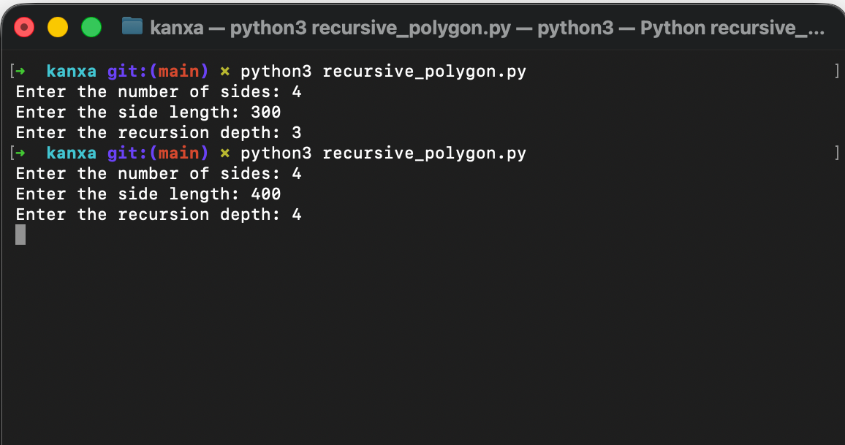
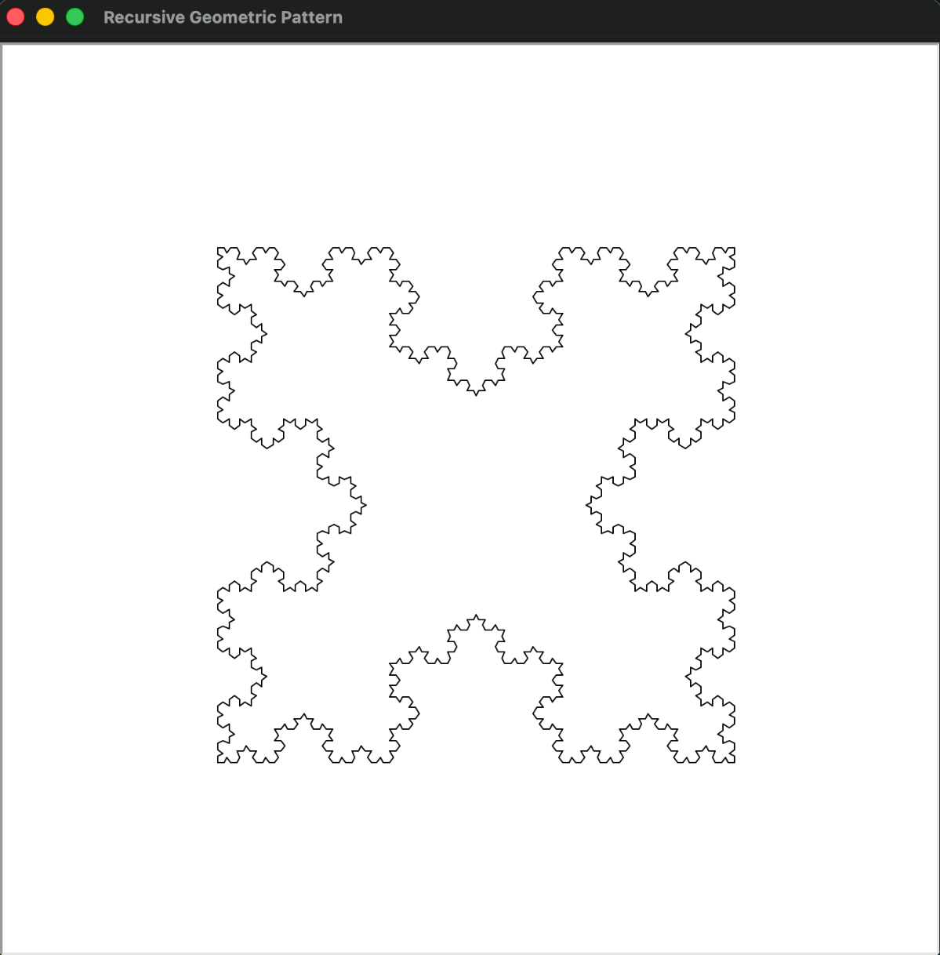

Group Collaboration
Our group SYDN 54 divided responsibilities among the members during the 3rd December class session. The members had their individual part to complete in the assignment.
A follow-up group meeting was organized through Microsoft Teams on 11th December to be sure that all the work was accurate, consistent, and properly integrated. Three members of the group were actively involved by use of chat and live video call. It was also a platform at the meeting where it was established that the updated sections were ready and compiled to be reviewed finally.

Involvement and Interaction.
Communication was done in two principal forms:
Microsoft Teams Chat: The members talked of the general meeting group or forming a special meeting. Updates on the progress were provided, such as on accomplishment of individual tasks. All of the members provided python code files as the evidence of the work contribution.
Video Meeting of Microsoft Teams: The meeting was attended by all the three members, Luminous Suwal, Subish Shakya and Mim Maya Moktan. The discussion took more than an hour. Reviewing of tasks and work left was done together.
Contribution of Each Member
Luminous Suwal
- Formed Microsoft Teams group and invited all other members
- Initiated the team meeting using Microsoft Teams and active participant in the video discussion.
- Arranged discussion and supported unifying of members.
- The updates provided by all members were reviewed and ensured.
- Completed Question number 2.
Subish Shakya
- Actively chatted with group on Microsoft teams to remind members of their part
- Scheduled the group meeting and participated actively in the meeting.
- Mutual reports on what he was to do.
- Helped in the last verification and unification of all individual contributions in the group.
- Completed Question number 4.
Mim Maya Moktan
- Active in Teams chat in the discussion of the meeting arrangements.
- Reported on her designated share of work.
- Participated in the discussions of the video meeting.
- Completed Question number 1.
Yonish Tamang
- Actively chatted with group on Microsoft teams.
- Reported on his designated share of work.
- Shared his code file in the Microsoft Teams group.
- Completed Question number 3.
Evidence of Collaboration
Teams Chat Messages: Displaying planning, updates and shared files.
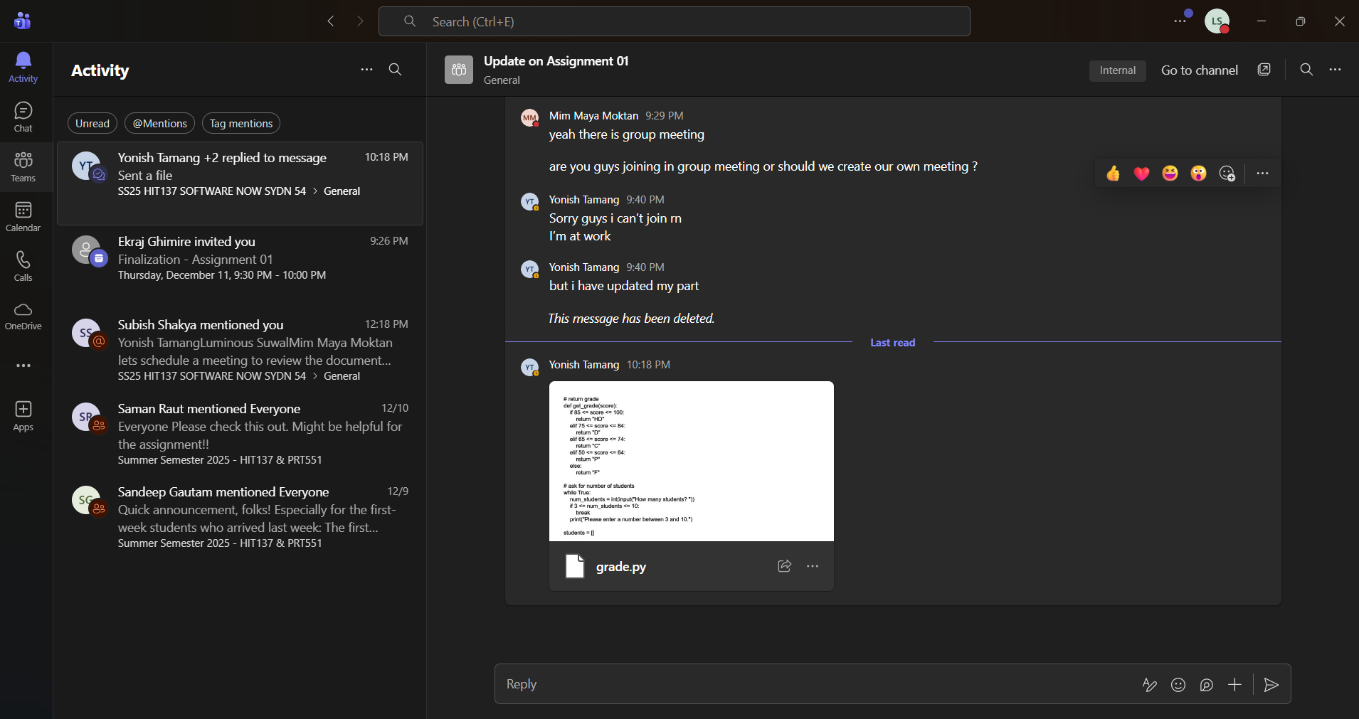

Shared Code Files: These are the code files that were sent by each member as evidence of their part completion.
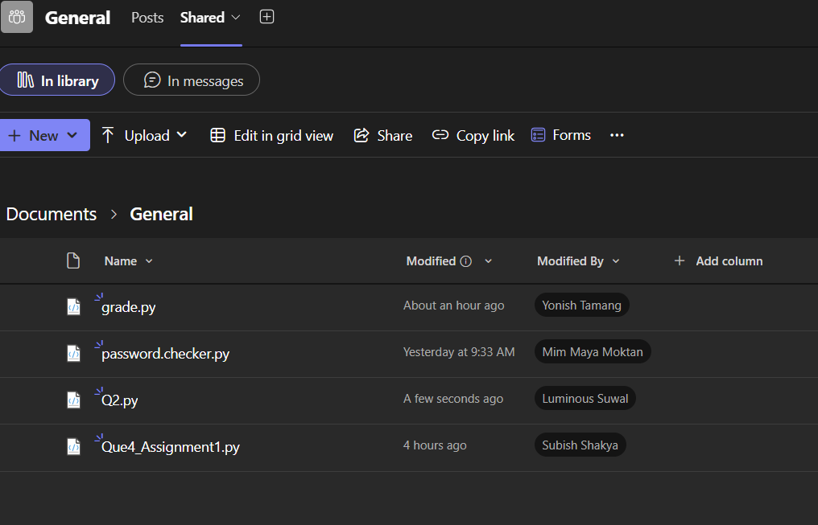

Teams Meeting Screenshot: Displays everyone who is a part of the group that is involved in the call.
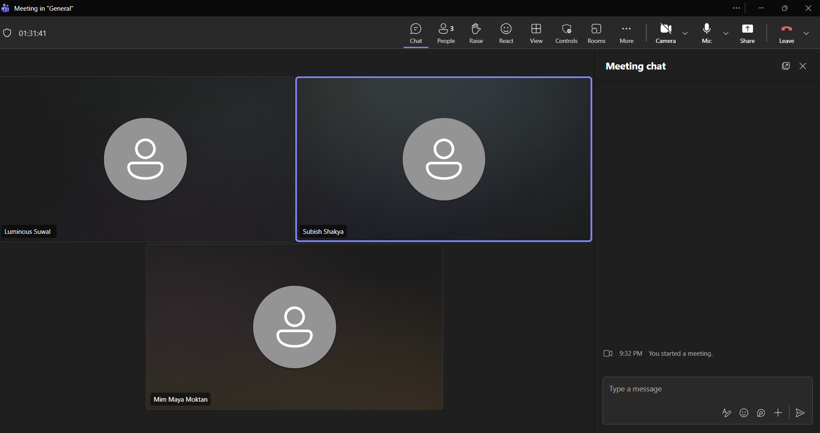

Teamwork and communication in the group were also strong. Every member had an equal portion of the workload, had an open-line communication of progress, and maintained cooperation via the joint use of chat messages and live video conversation. The interaction was suitable to provide an appropriate coordination, execution of tasks on time, and a cohesive final submission.

References

[1] | OpenAI, "ChatGPT," 2025. [Online]. Available: https://chatgpt.com/.
[2] | [Online]. Available: https://www.w3schools.com/python/python_ref_string.asp.
[3] | "w3schools.com," [Online]. Available: https://www.w3schools.com/python/python_strings.asp.
[4] | "w3schools.com," [Online]. Available: https://www.w3schools.com/python/python_strings_slicing.asp.
[5] | "w3schools," [Online]. Available: https://www.w3schools.com/python/python_strings_modify.asp.
[6] | "w3schools," [Online]. Available: https://www.w3schools.com/python/python_strings_concatenate.asp.
[7] | [Online]. Available: https://www.w3schools.com/python/python_strings.asp.
[8] | Programiz, "Python Program to Check Prime Number," [Online]. Available: www.programiz.com. [Accessed 2025].
[9] | R. Mishra, "Final Python Project - Password Strength Checker Tool | Python Tutorial in Hindi," 5 1 2025. [Online]. Available: https://www.youtube.com/watch?v=pbKZ-dmUBis.
[10] | w3schools, "Python input() Function," [Online]. Available: https://www.w3schools.com/python/ref_func_input.asp.
[11] | w3school, "Python len() Function," [Online]. Available: https://www.w3schools.com/python/ref_func_len.asp.

